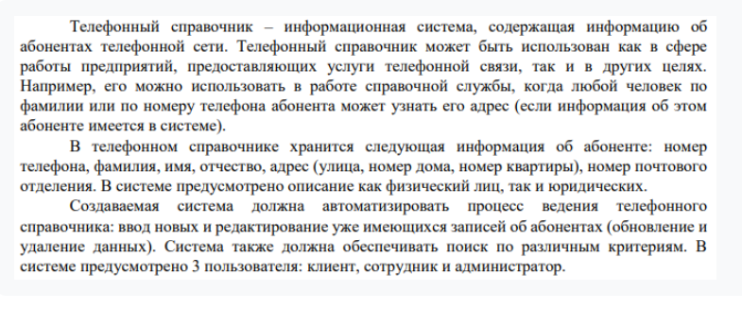

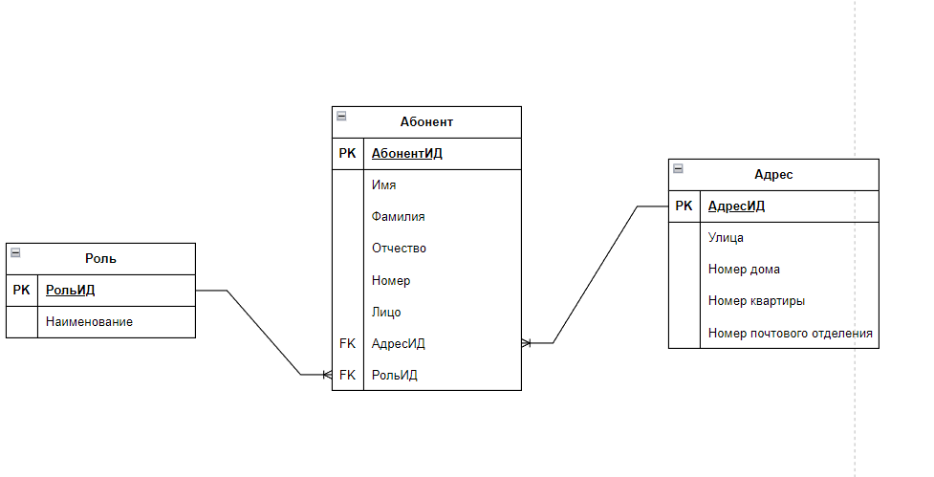

|  |
| --- |
| **CREATE** **TABLE** Address (  AddressID SERIAL **PRIMARY** **KEY**,  Street **VARCHAR**(100),  HouseNumber **VARCHAR**(10),  ApartmentNumber **VARCHAR**(10),  PostOfficeNumber **VARCHAR**(20)  );  **CREATE** **TABLE** **Role** (  RoleID SERIAL **PRIMARY** **KEY**,  **Name** **VARCHAR**(50) **UNIQUE**  );  **CREATE** **TABLE** Subscriber (  SubscriberID SERIAL **PRIMARY** **KEY**,  FirstName **VARCHAR**(50),  LastName **VARCHAR**(50),  MiddleName **VARCHAR**(50),  PhoneNumber **VARCHAR**(20),  EntityType **VARCHAR**(20) **CHECK** (EntityType **IN** (**'Физическое лицо'**, **'Юридическое лицо'**)),  AddressID **INT** **REFERENCES** Address(AddressID) **ON** **DELETE** **SET** **NULL**,  RoleID **INT** **REFERENCES** **Role**(RoleID) **ON** **DELETE** **SET** **NULL**  ); |